Install GIT & make sure it is added into PATH.

Section 0 -Use GIT as local VCS. Steps to follow:

1. Create a directory ‘project_dir’ & cd to ‘project_dir’.

**Ans:- mkdir project_dir & cd project_dir**

1. Initialize git version database. (git init)

**Ans:- git init**

1. Create a new file index.html.

**Ans :- touch index.html**

1. Check the git status. You should find index.html as untracked file.

**Ans :- check status**

1. Stage the index.html file.

**Ans :- git add index.html**

1. Commit index.html

**Ans :- git commit -m "commiting the index file"**

1. Make few changes in index.html & create a new file info.txt file.

**Ans :- code index.html make changes & touch info.txt**

1. Check git status. You should find index.html & info.txt as untracked files.

**ANS :- git status**

1. Configure GIT to ignore all txt files.

**Ans :- touch .gitignore , code .gitignore , *.txt in ‘.gitignore’.**

1. Again check the git status. You should find only index.html as untracked file.

**Ans :- git status**

1. State & commit index.html

**Ans :- git add index.html & git commit -m “second commit of index.html”**

1. Log all your comments so far.

**Ans :- git log**

1. Make some changes in index.html.

**Ans :- code index.html , git commit -am “third commit of index.html”**

1. Revert the change made in the previous step using git command.

**Ans :- git revert HEAD**

1. Again change index.html.

**Ans: - code index.html**

1. Stage index.html

**Ans :- git add index.html**

1. Revert back the last stage.

**Ans - git revert HEAD**

1. Rename ‘add’ command to ‘my-add’.

**Ans :- git config --global alias.my-add add**

1. Using my_add command Stage index.html again & commit the changes.

**Ans :- git my-add index.html , git commit -m "5th commit the index file"**

1. Revert the last commit.

**Ans :- git revert HEAD**

*GIT Branching*

Objective: Commit HTML, CSS & JavaScript assignments into GIT.

SECTION-1 (HTML assignments) - Steps to follow:

1. First take a backup of your assignments & projects. This is required because due to incorrect GIT operation you may lose your files.

**Ans :- git bundle create section0.bundle master**

1. Create an empty directory ‘Assignments’ & cd to ‘Assignments’.

**Ans :- mkdir Assignments & cd Assignments**

1. Create a file README.txt inside ‘Assignments’ & write few lines about the contents of ‘Assignments’ folder.

**Ans :- touch README.txt & vim README.txt**

1. Commit README.txt file.

**Ans :- git commit -am "readme commit"**

1. Now create a new branch ‘html-assignments’.

**Ans :- git branch html-assignments**

1. Switch to ‘html-assignments’ branch.

**Ans :- git checkout html-assignments**

1. Copy all HTML assignments inside ‘Assignments’ folder.

**Ans :- cp *.html Assignments/**

1. Commit HTML assignments into ‘html-assignments’ branch.

**Ans :- git commit -m "commiting HTML assignments into html-assignments branch"**

1. Make minor changes into few files belonging to ‘html-assignments’ branch.

**Ans :- vim index.html**

1. Commit those changed files.

**Ans :- git add index.html & git commit -m "commiting HTML changes into html-assignments branch"**

1. Switch to master branch.

**Ans :- git checkout master**

1. Make minor changes into README.txt file & commit those changes into master.

**Ans :- vim README.txt & git commit -am "2nd readme commit"**

1. Again switch to ‘html-assignments’ branch.

**Ans :- git checkout html-assignments**

1. Make minor changes into few files belonging to ‘html-assignments’ branch.

**Ans :- vim index.html**

1. Commit those changes.

**Ans :- git commit -am "html changes"**

1. Switch to master.

**Ans :- git checkout master**

1. Merge ‘html-assignments’ branch into master. Confirm all html assignments are shown in master.

**Ans :- git merge html-assignments**

1. Finally delete the ‘html-assignments’ branch.

**Ans :- git branch -d html-assignments**

SECTION-2 - (CSS assignments) Steps to follow:

1. Create a new branch ‘css-assignments’.

**Ans :- git branch css-assignments**

1. Switch to ‘css-assignments’ branch.

**Ans :- git checkout css-assignments**

1. Copy all CSS assignments inside ‘Assignments’ folder.

**Ans :- cp *.css Assignments/**

1. Commit CSS assignments into ‘css-assignments’ branch.

**Ans :- git commit -m "css commit 1”**

1. Make minor changes into README.txt file on line 1 belonging to ‘css-assignments’ branch.

**Ans :- vim README.txt**

1. Commit those changed files.

**Ans :- git commit -am "README.txt changes"**

1. Switch to master branch.

**Ans :- git checkout master**

1. Make minor changes into README.txt file on line 3 & commit those changes into master.

**Ans :- vim README.txt & git commit -am "README.txt master changes"**

1. Again switch to ‘css-assignments’ branch.

**Ans :- git checkout css-assignments**

1. Make minor changes into few files belonging to ‘css-assignments’ branch.

**Ans :- vim index1.html**

1. Commit those changes.

**Ans :- git commit -am "commiting css assignments minor changes"**

1. Switch to master.

**Ans :- git checkout master**

1. Merge ‘css-assignments’ branch into master. Confirm all css assignments are shown in master.

**Ans :- git merge css-assignments**

1. Finally delete the ‘css-assignments’ branch.

**Ans :- git branch -d css-assignments**

SECTION-3 - (JavaScript assignments) Steps to follow:

1. Create a new branch ‘js-assignments’.

**Ans :- git branch js-assignments**

1. Switch to ‘js-assignments’ branch.

**Ans :- git checkout js-assignments**

1. Copy all JavaScript assignments inside ‘Assignments’ folder.

**Ans :- cp index.js Assignments/**

1. Commit JavaScript assignments into ‘js-assignments’ branch.

**Ans :- git commit -m "js-assignment js commit"**

1. Make minor changes into README.txt file on line 1 belonging to ‘js-assignments’ branch.

**Ans :- vim README.txt**

1. Commit those changed files.

**Ans :- git commit -am "README.txt js assignment commit"**

1. Switch to master branch.

**Ans :- git checkout master**

1. Make minor changes into README.txt file on line 1 & commit those changes into master.

**Ans :- git commit -am “master readme.txt commit”**

1. Again switch to ‘js-assignments’ branch.

**Ans :- git checkout js-assignments**

1. Make minor changes into few files belonging to ‘js-assignments’ branch.

**Ans :- vim index.js**

1. Commit those changes.

**Ans :- git commit -am "js-assignment index.js commit"**

1. Switch to master.

**Ans :- git checkout master**

1. Merge ‘js-assignments’ branch into master. Confirm all JavaScript assignments are shown in master.

**Ans :- git merge js-assignments**

1. Finally delete the ‘js-assignments’ branch.

**Ans :- git branch -d js-assignments**

Final log:-

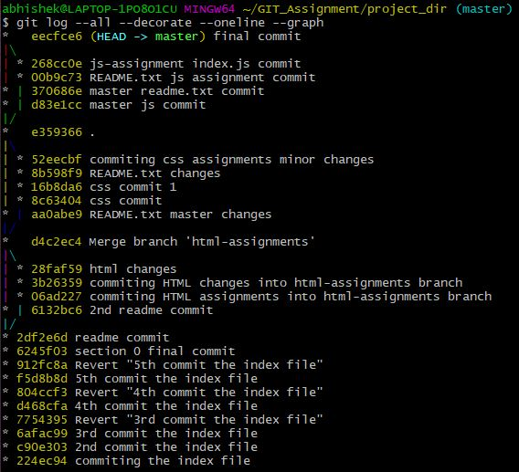

*GIT Remoting*

Objective: Pushing source code into GITHUB & collaborate team members.

SECTION-3 (Pushing assignments to remote repository) - Steps to follow:

1. Create a github account if you do not have already.
2. Login on into github account.
3. Create new public repository ‘freshersbatch-oct16’.

**Ans:- Click NEW button to create new repository**

1. Commit & push any sample file to this repository under ‘Assignments’ directory.

**Ans:- git config --global user.name ‘abhiyadav599'**

**git config --global user.email ‘abhishek.hariram.yadav’**

**git remote add origin <https://github.com/abhiyadav599/Abhisek-Yadav_Assignments.git>**

**git branch -M main**

**git push -u origin main**

SECTION-4 (Pushing source code to remote repository using Eclipse GIT plugin) - Steps to follow:

1. One developer from project team will create eclipse projects ‘SampleProj’ & add sample source code files. Then commit all files through eclipse GIT plugin.
2. Collaborate other team members with your github account so that they can also modify the committed files.
3. Other developers from same team will checkout all files from remote repository. This might get conflicts since certain files fail to merge. In such case, merge it manually.
4. Commit & push the ‘SampleProj’ project.